**Crappie Tournament Rules**

1. This is a team tournament. One or two anglers make up a team.
2. If changing a team member, you must inform the tournament director by e-mailing pymalakeassoc@gmail.com or by calling 724-418-1501.
3. No team member shall be on the water for eight (8) hours prior to the tournament.
4. All crappie must be caught from Pymatuning lake. Hatchery waters are off limits.
5. All crappie must be caught during tournament hours 6 am till 2:30 pm and team entrants must be in the weigh in line no later than 3:30 pm or the team will be disqualified.
6. No passengers and/or spectators allowed with the team while tournament fishing.
7. Each team will consist of no more than 2 people per team. Single member teams are permitted but must pay the $45 entry fee.
8. Each team must fish together as a team. One team per boat, if fishing from a boat – this includes pontoons
9. All crappie must be caught on a rod and reel.
10. All entrants must follow all state regulations along with all boating and fishing regulations while fishing in the crappie tournament.
11. All crappie must be ALIVE when they are brought to weigh-in.
12. Teams may bring up to five (5) of their largest crappie to the scales. Teams bringing more than 5 to the weigh in will be disqualified.
13. Total weight of your five (5) crappie will determine the winner.
14. One (1) “Big Fish” per team will be weighed in at the scales for entry in to the big fish weight category.
15. All ties will be broken by the flip of a coin ***or*** they may choose to split the winnings.
16. The tournament director has the right to disqualify any questionable fish.
17. The tournament director, who reserves the right to make additional rules conducting the crappie tournament if circumstances require the change, will make all decisions in compliance with these rules and the interpretation of these rules.
18. Failure to follow the event rules may result in disqualification.
19. All winners are subject to a polygraph test. Any entrant who refuses or fails the polygraph test will be disqualified and will not be eligible for prizes.
20. The Pymatuning Lake Association, Pymatuning State Park (PA DCNR), Ohio Pymatuning State Park (ODNR), PA Fish and Boat Commission and any sponsors are not responsible for any theft or injury that may occur at the event.
21. Pre-registered teams are NOT required to check in prior to the start of the event. Registered teams may launch from any boat ramp on the lake.
22. Prizes will be awarded following the completion of the weigh in.
23. Weigh in location, southeast side of the causeway, at the Pymatuning lake association pavilion at the Espyville boat launch. Watch for the tournament signs.
24. Please help support catch and release…. Only keep what you plan to weigh in.
25. Upon entering the crappie tournament, you hereby grant the sponsors the unconditional right to use your name and or photograph in any articles or press releases, but not as an endorsement.
26. Each team will receive a ticket during weigh in for the door prizes whether they caught a fish or not.
27. Returned checks + non-sufficient funds (NSF) or for any other reason will be assessed a $30 fee in addition to our banks service charges.
28. The tournament director has the right to reduce the payout of prizes if there are less than 100 entrants. The payouts would be reduced proportionally to the percentage of reduction of entrants from 100.

**Pymatuning Lake Association’s Crappie Tournament! Saturday April 27th 2024**

**“Open to the public”**

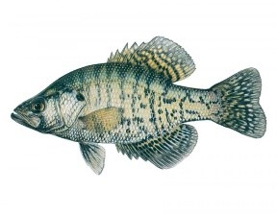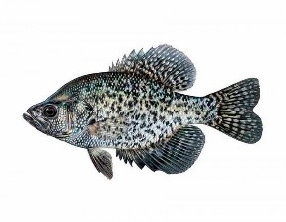

**FIVE** FISH TOTAL WEIGHT

|  |  |
| --- | --- |
| 1st Place | $500 |
| 2nd Place | $400 |
| 3rd Place | $300 |
| 4th Place | $200 |
| 5th Place | $150 |
| 6th Place | $100 |
| 7th Place | $ 50 |

BIG FISH

1ST Place $300

*Payouts are based on 100 teams.*

*Payouts will be reduced proportionately if there are less than 100 teams.*

# Weigh-in and Late Registration

Pymatuning Lake Association’s Pavilion at the Espyville Boat Launch. Late registration 6 AM to 8 AM on Saturday April 27th,2024

**Pymatuning Lake Association contact info:**

**Phone:** 724-418-1501

**Address:** P.O. Box 78, Westford, PA 16134

**E-Mail:** Pymalakeassoc@gmail.com

# Results will be posted to our Facebook page